Name:- Document-2
Solution:-

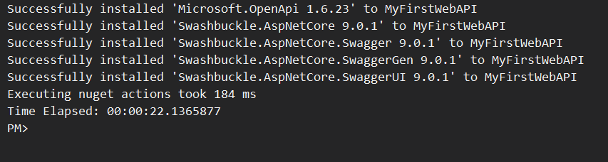

Enable Swagger:

using Microsoft.OpenApi.Models;

var builder = WebApplication.CreateBuilder(args);

builder.Services.AddControllers();
builder.Services.AddEndpointsApiExplorer();
builder.Services.AddSwaggerGen(c =>
{
c.SwaggerDoc("v1", new OpenApiInfo
{
Title = "Swagger Demo",
Version = "1.0.0",
Description = "API for demonstration",
TermsOfService = new Uri("https://example.com/terms"),
Contact = new OpenApiContact
{
Name = "John Doe",
Email = "john@xyzmail.com",
Url = new Uri("https://example.com")
},
License = new OpenApiLicense
{
Name = "License",
Url = new Uri("https://example.com")
}
});
});

var app = builder.Build();
app.UseSwagger();
app.UseSwaggerUI(c =>
{
c.SwaggerEndpoint("/swagger/v1/swagger.json", "Swagger Demo v1");
});
app.MapGet("/", () => Results.Redirect("/swagger"));

app.UseHttpsRedirection();
app.UseAuthorization();
app.MapControllers();
app.Run();

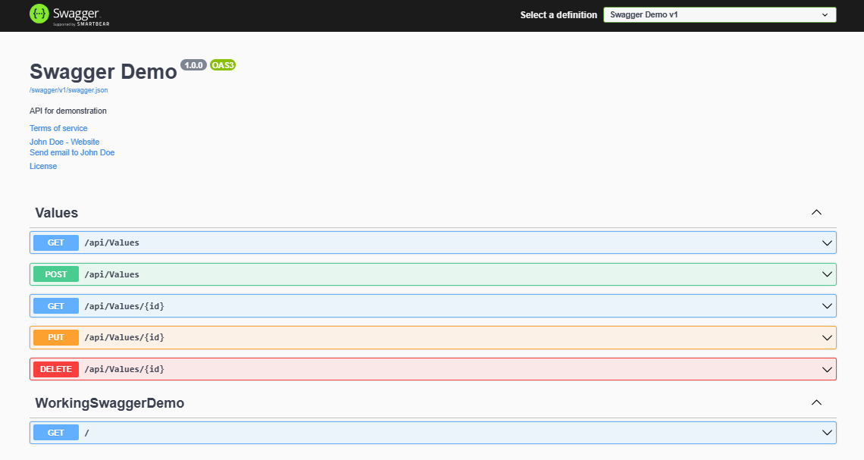

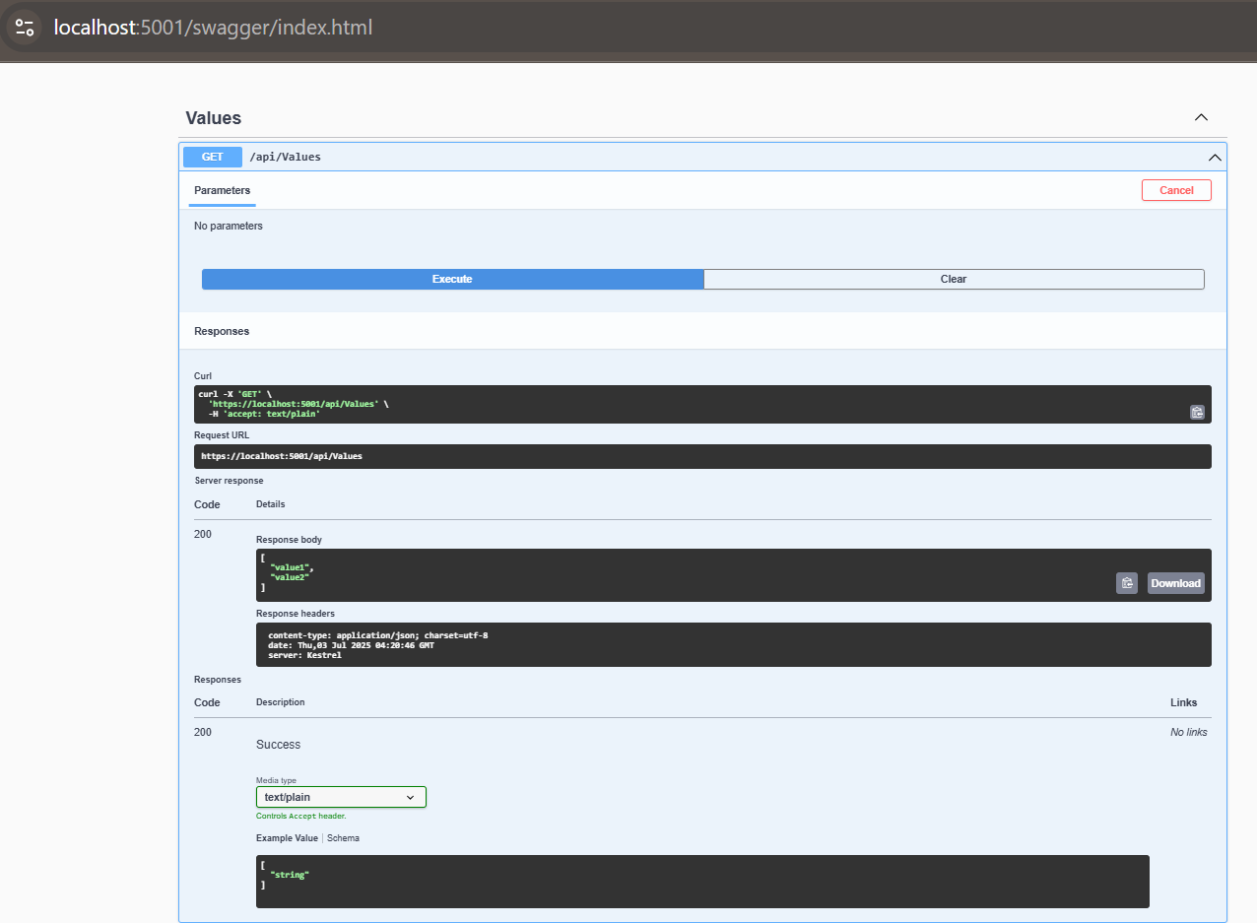

2.

Code for EmployeeController.cs in Controllers to Get in Postman:

using Microsoft.AspNetCore.Mvc;
using WorkingSwaggerDemo.Models;

namespace WorkingSwaggerDemo.Controllers
{
[ApiController]
[Route("api/Emp")]
public class EmployeeController : ControllerBase
{
private static List<Employee> employees = new List<Employee>()
{
new Employee { Id = 1, Name = "Mickey", Department = "IT" },
new Employee { Id = 2, Name = "Rahul", Department = "HR" }
};
[HttpGet]
public ActionResult<IEnumerable<Employee>> Get()
{
return Ok(employees);
}
[HttpPost]
public IActionResult Post([FromBody] Employee emp)
{
if (emp == null || string.IsNullOrWhiteSpace(emp.Name))
return BadRequest("Invalid employee data.");

employees.Add(emp);
return Ok("Employee added");
}
}
}

Code for ValuesController.cs in Controllers to Get in Postman

using Microsoft.AspNetCore.Mvc;

namespace WorkingSwaggerDemo.Controllers
{
[ApiController]
[Route("api/Values")]
public class ValuesController : ControllerBase
{
[HttpGet]
public ActionResult<IEnumerable<string>> Get()
{
return Ok(new string[] { "value1", "value2" });
}

[HttpGet("{id}")]
public ActionResult<string> Get(int id)
{
if (id <= 0)
return NotFound("Invalid ID");

return Ok($"You requested value {id}");
}

[HttpPost]
public IActionResult Post([FromBody] string value)
{
if (string.IsNullOrWhiteSpace(value))
return BadRequest("Value cannot be empty");

return Ok($"You posted: {value}");
}

[HttpPut("{id}")]
public IActionResult Put(int id, [FromBody] string value)
{
if (id <= 0 || string.IsNullOrWhiteSpace(value))
return BadRequest("Invalid input");

return Ok($"You updated ID {id} with value {value}");
}

[HttpDelete("{id}")]
public IActionResult Delete(int id)
{
if (id <= 0)
return NotFound("Invalid ID");

return Ok($"You deleted value with ID {id}");
}
}
}

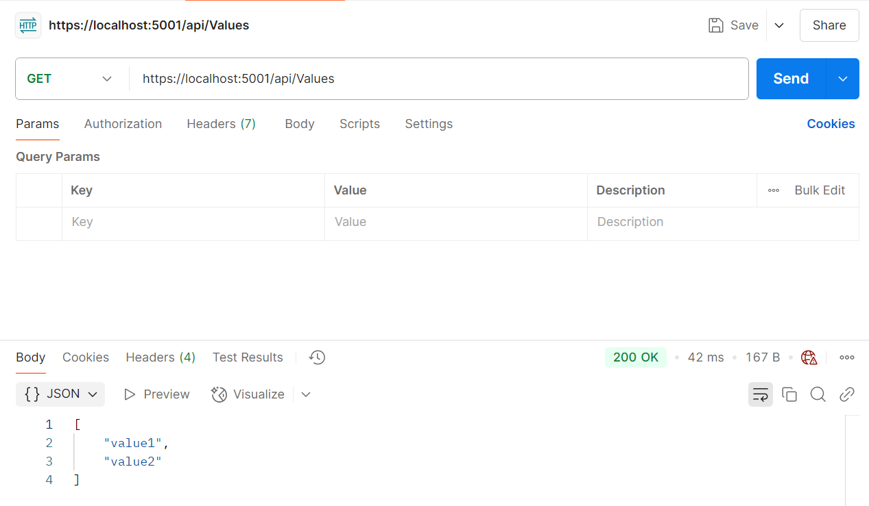

A. GET Request
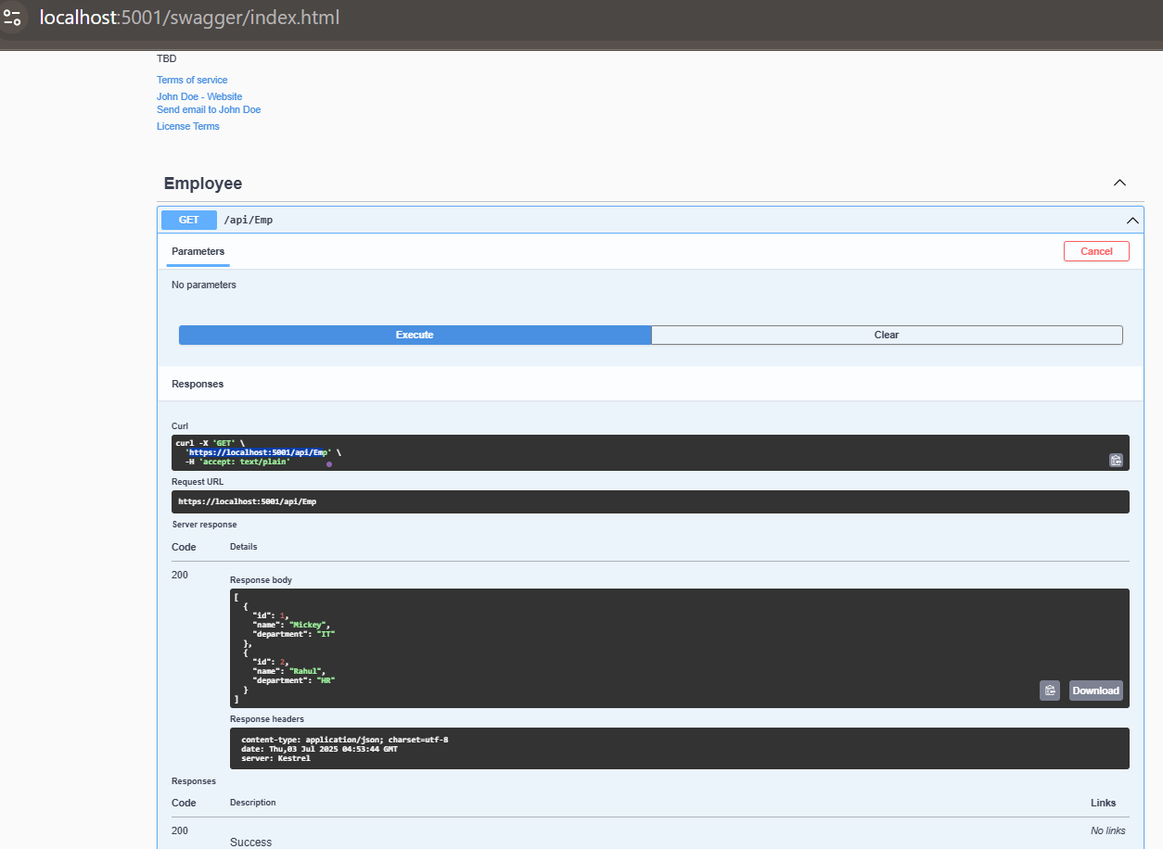
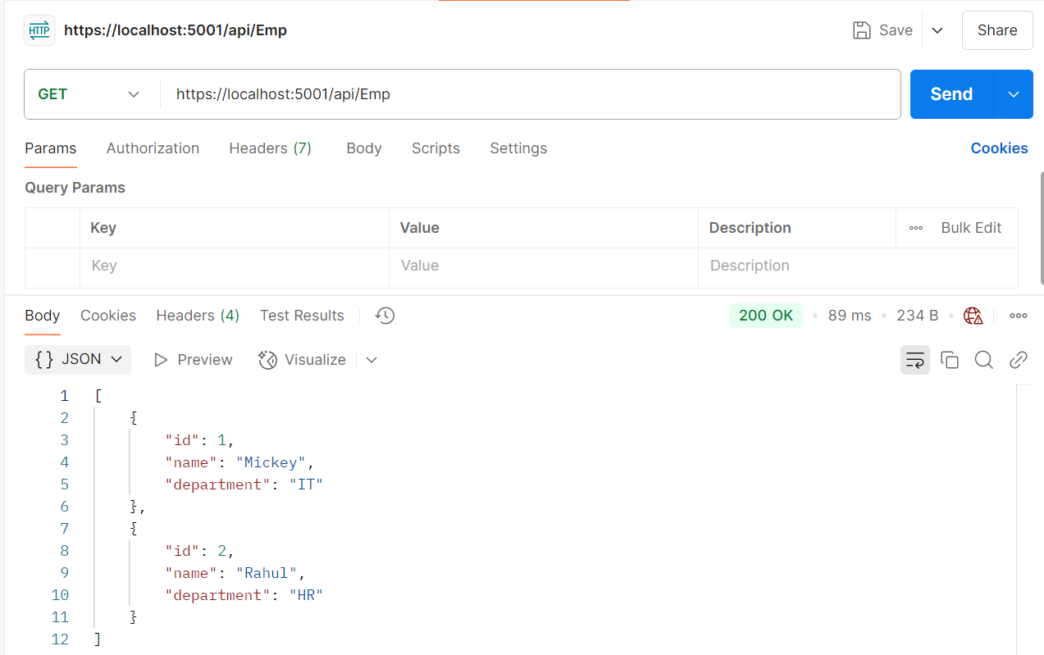

B. POST Request

using Microsoft.AspNetCore.Mvc;

namespace WorkingSwaggerDemo.Controllers
{
[ApiController]
[Route("api/Emp")]
public class EmployeeController : ControllerBase
{
[HttpPost]
public IActionResult Post([FromBody] string name)
{
if (string.IsNullOrWhiteSpace(name))
return BadRequest("Name cannot be empty");

return Ok($"Employee added: {name}");
}
}
}

Checking on Local Server:
